User Guide

Step 1 :

Creat a folder in your desktop and name it « Script »

Step 2 :

Download the csv files in the « Script » directory

Step3 :

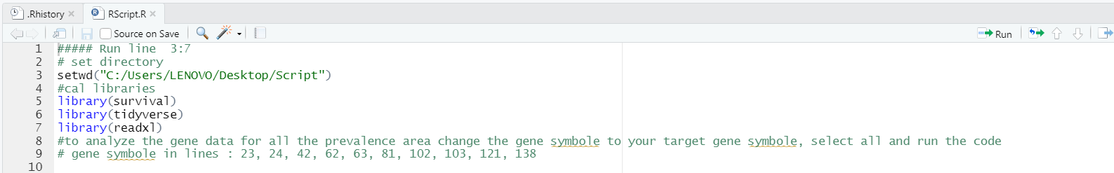Download the R script and open it with R studio

Step 4 :

Run lines 3 to 7

Step 5 :

Change the Gene symbole to your target gene symbol

Step 5 :

Run the Script

>> Result will be automaticly exported in txt files in the « Script « folder

1. Genetic Differencial Expression

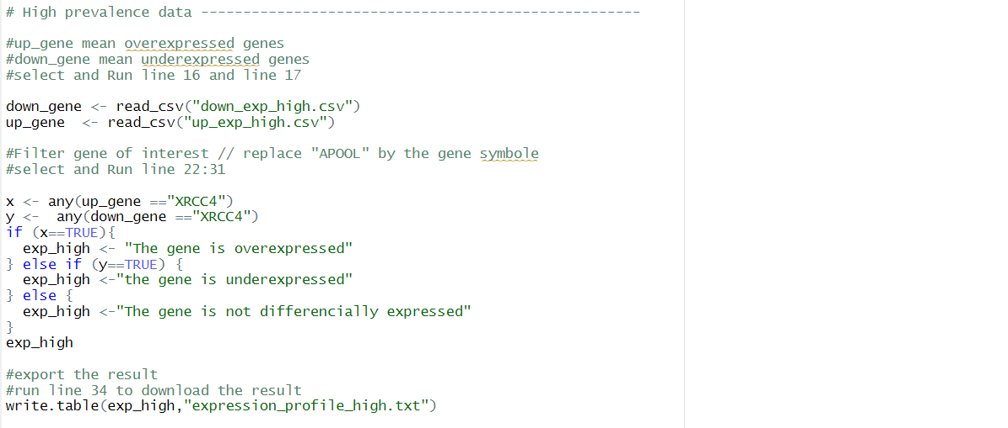

Search your target gene in the lists

Import the over expressed and the under expressed gene list

Output options :

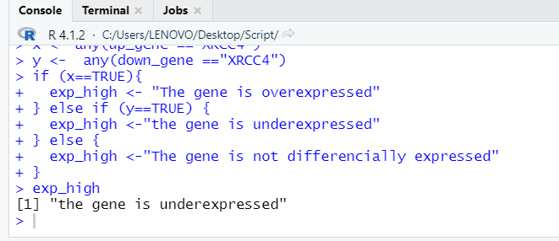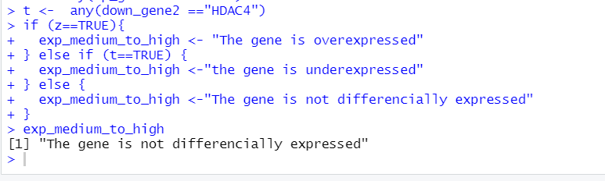

1. Methylation of CpGs in the promoter

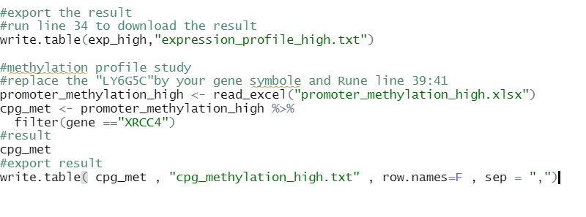Output options :

If there is methylated CpG s in the promoter region of the gene

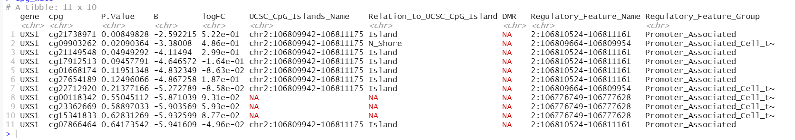

If there is no methylated CpG s

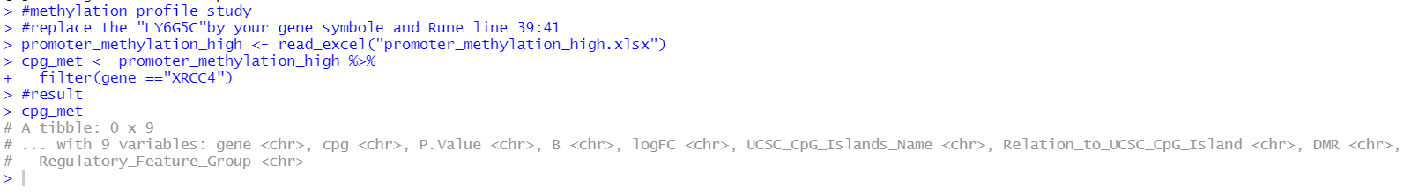

1. Regulatory miRNAs

